CHECK IN PROCESS

Pre Requisite:

1. GitHub Access
2. Install any Git Desktop client (Preferred SourceTree, Provide your Git credentials and select “Download Git client” while installing SourceTree)

Setup Environment:

1. Fork upstream repository (<https://github.com/dell-asm/gui-automation>) from GitHub UI, which creates a local repository with your Git username like ([https://github.com/<git-username>/gui-automation](https://github.com/%3cgit-username%3e/gui-automation)). This is one time job

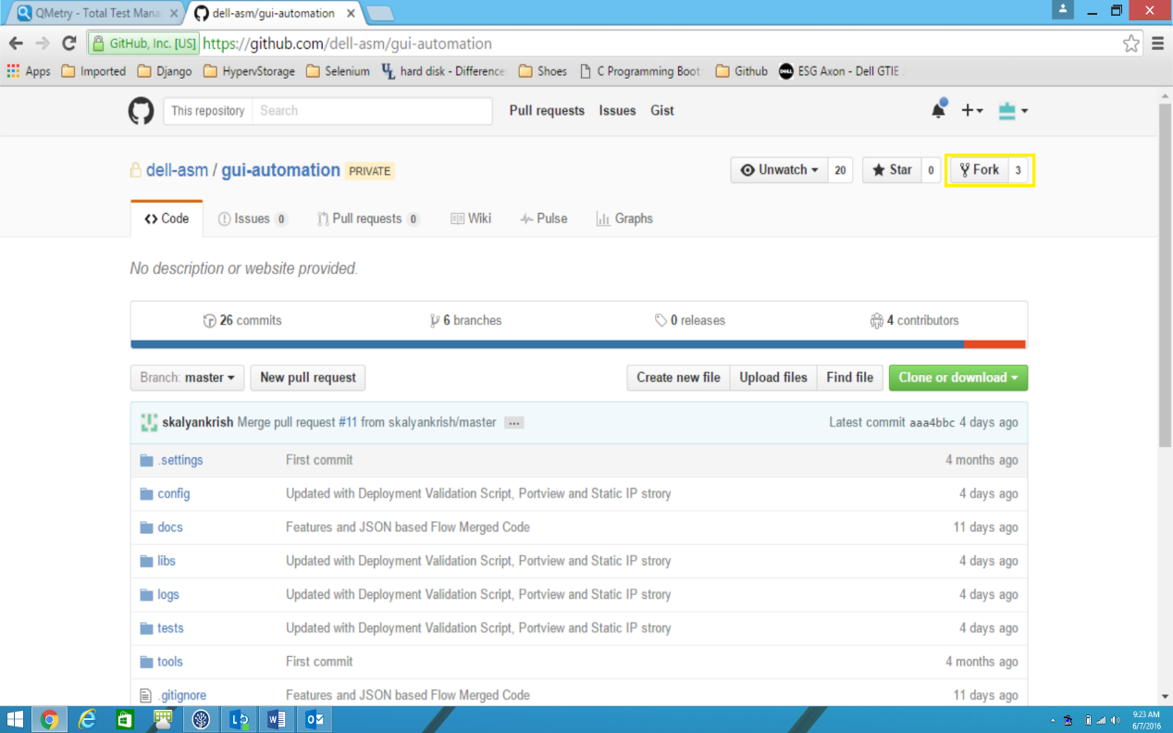

1. Clone forked repository from SourceTree by providing forked repo URL like ([https://github.com/<git-username>/gui-automation](https://github.com/%3cgit-username%3e/gui-automation)) and select local folder path where to clone.

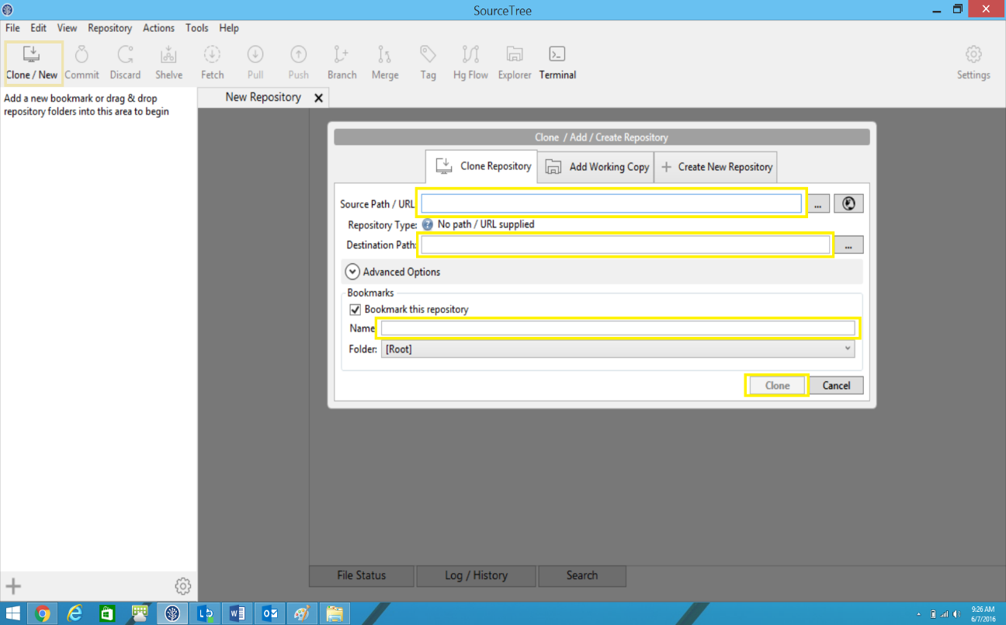

1. Add Upstream Repository in SourceTree by providing URL (<https://github.com/dell-asm/gui-automation>)

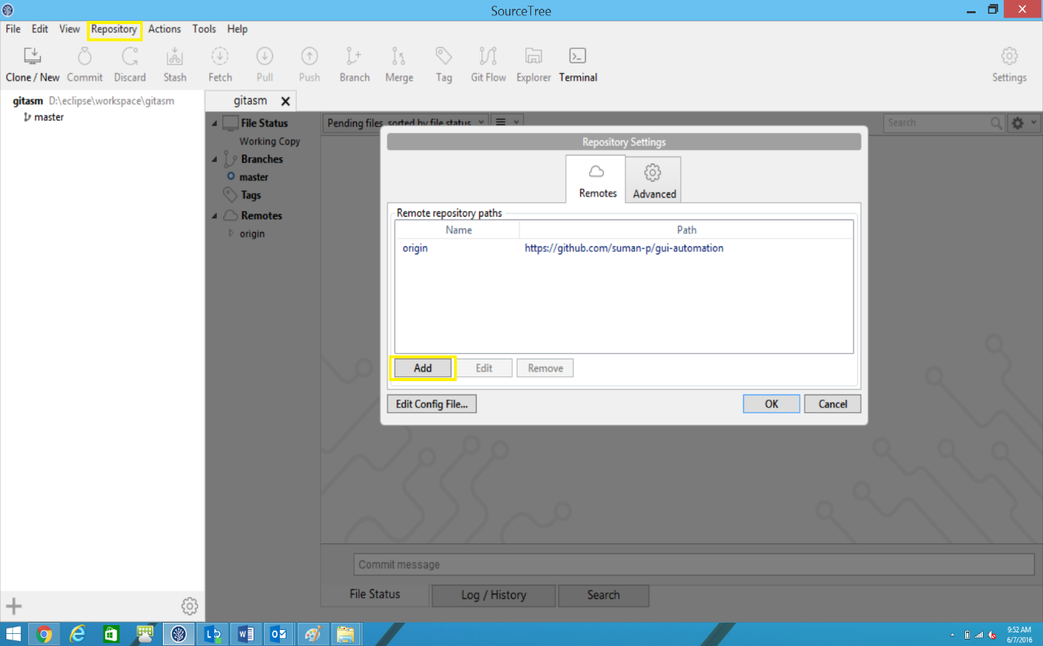

Content Automation Process:

1. Before automating any feature or story checkout new branch from upstream/master to your local repository and add your content to the newly created branch

Branch Name should be <Feature Name>_<JIRA Num for that Story>

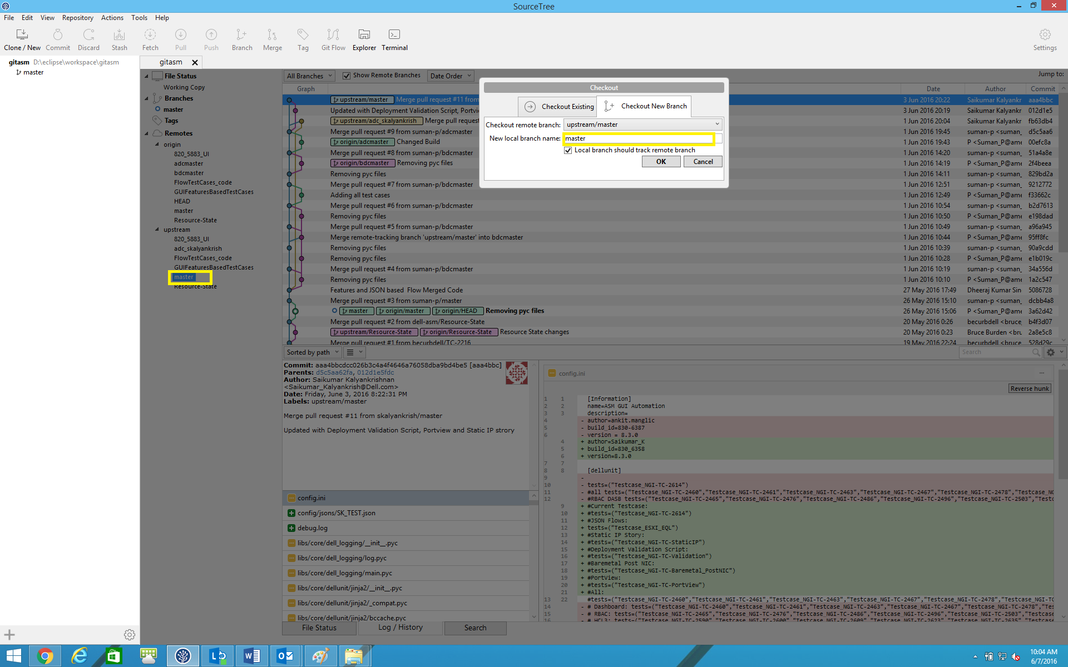

1. Commit changes to local repository and add comments about changes
2. Push changes to Local Repository
3. From GitHub UI raise a Pull Request to merge code to upstream master
4. Code has to be reviewed by any one of the peer before merging into upstream/master.

Reviewer has to leave a comment about the pull request and initiate a Merge with upstream/master.